Data Science Job Market Analysis

Rabin Acharya
Data Visualization Final Project
Instructor: John Koenig
March 7, 2026

Introduction
The demand for data scientists has grown as companies increasingly rely on data to make decisions. Many industries now hire data professionals to analyze data and improve business strategies. Understanding job market trends helps identify which industries hire the most data scientists and which skills are most important.
This paper briefly analyzes job postings for data science roles to understand salary patterns, industry demand, and commonly required technical skills.
Data and Method
The dataset contains job postings for data science roles and includes variables such as company name, industry, company age, average salary, rating, and required technical skills. The data was cleaned and analyzed using Python.
Data visualizations were created using Matplotlib, including bar charts and scatter plots. These visualizations help show patterns in hiring demand, salary differences, and skill requirements.
Results
Figure 1: Average Salary by Company Age
Figure 1 shows that younger companies have larger salary variations for data science jobs. The highest salaries appear in companies under 100 years old, while older companies tend to offer more stable and consistent salary ranges.

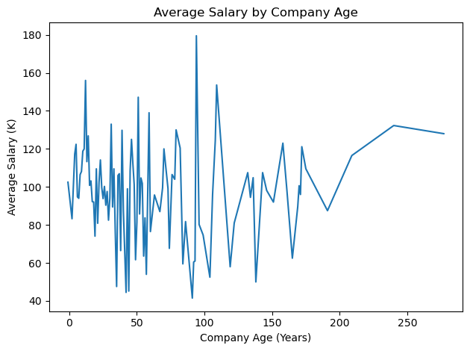
Figure 2: Top Industries Hiring Data Scientists
Figure 2 shows that Biotech and Pharmaceuticals have the highest number of data science job postings. Insurance and Computer Hardware and Software also show strong demand, indicating high opportunities in healthcare, finance, and technology industries.

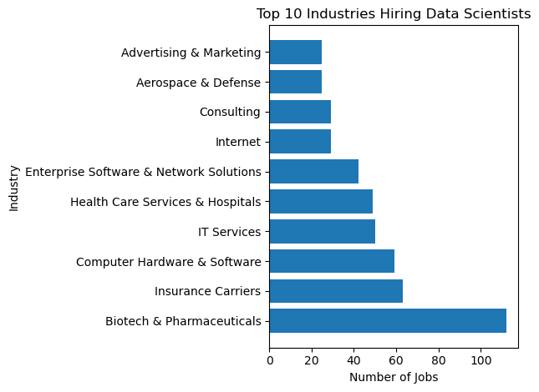
Figure 3: Job Ratings vs Average Salary
Figure 3 shows that there is no strong relationship between company ratings and salary levels. Most companies have ratings between 3.0 and 4.5, but salaries still vary widely.

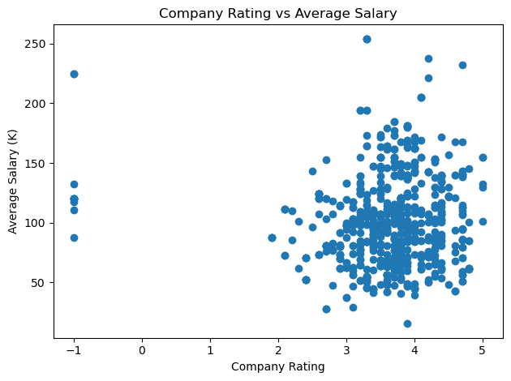
Figure 4: Most Required Skills
Figure 4 shows that Python, SQL, and Excel are the most required skills in data science job postings. Other tools like AWS, Spark, and Tableau appear less frequently.

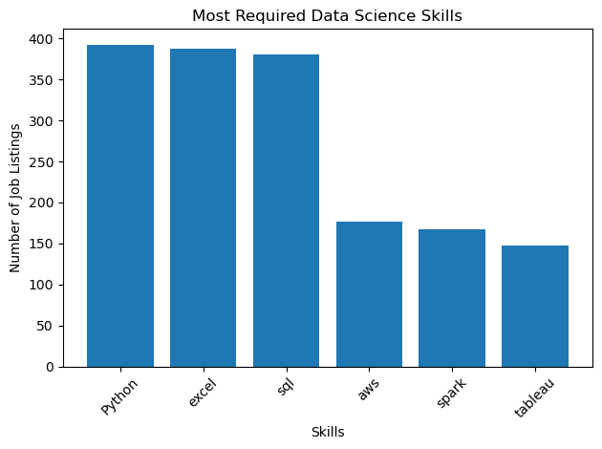
Figure 5: Average Salary by Sector
Figure 5 shows that most sectors offer average salaries above $100,000. Media, Accounting and Legal, and Information Technology offer slightly higher salaries, but the differences between sectors are small.
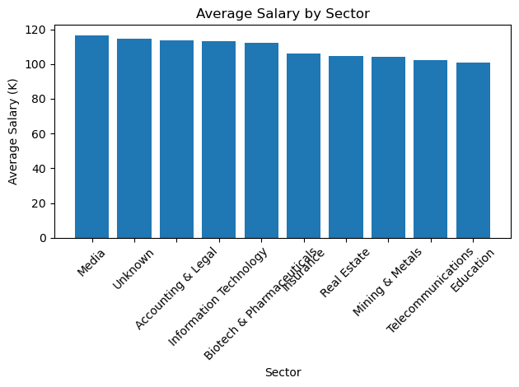

Conclusion
The data science job market is growing and concentrated in specific industries. Salaries can vary depending on company characteristics and sector. However, programming and data analysis skills such as Python and SQL remain essential for most data science positions.

